Función Generadora de Dimensión Fecha

Esta función personalizada de Power Query genera automáticamente una tabla calendario (dimensión fecha) completa con múltiples columnas de análisis temporal. Solo requiere dos parámetros: fecha de inicio y fecha final.
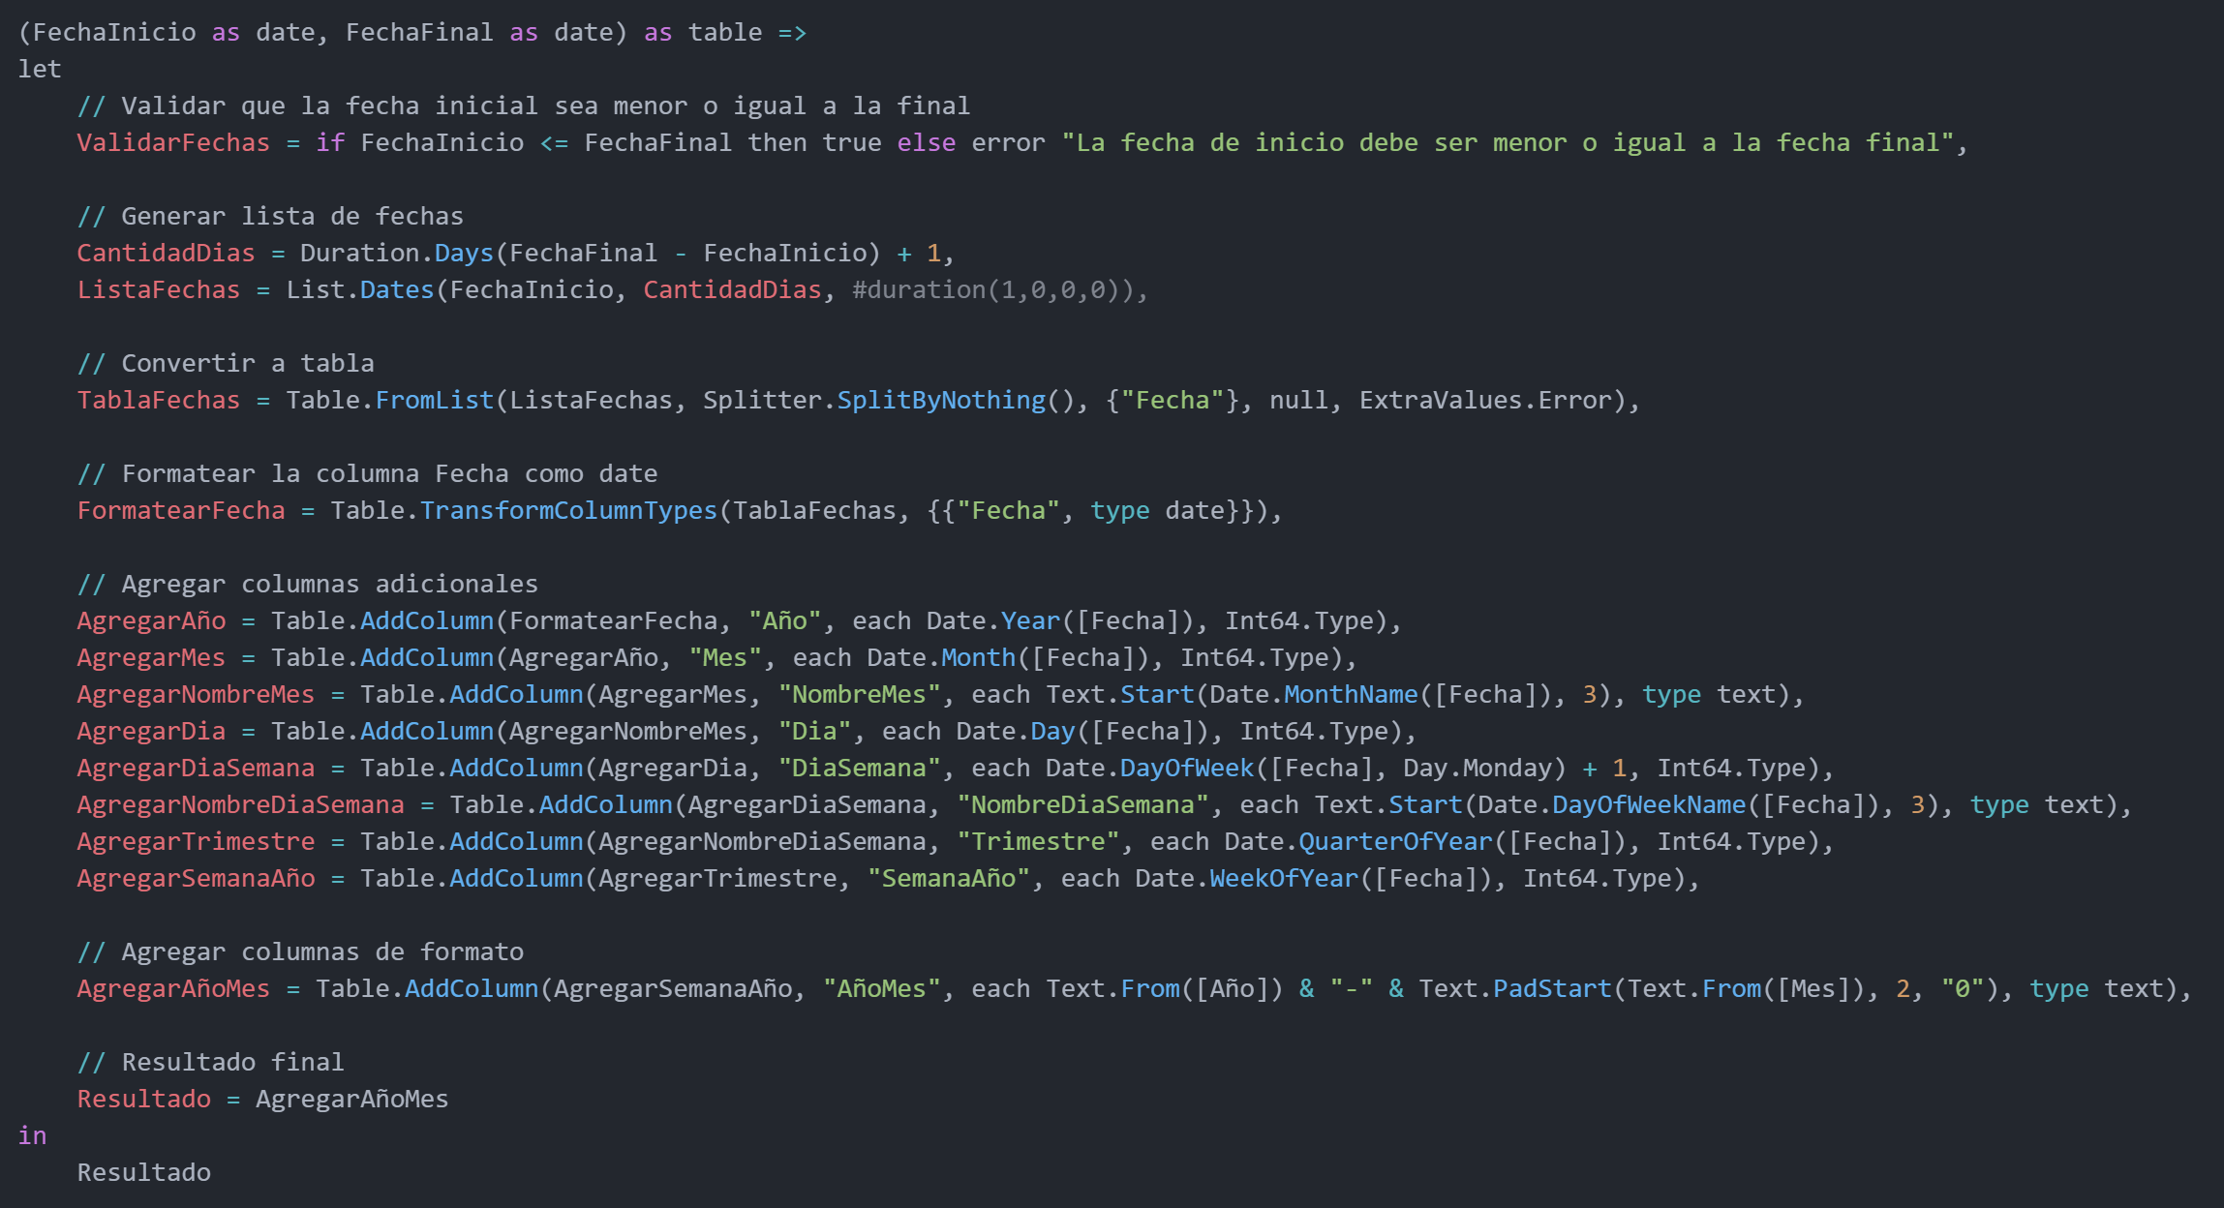
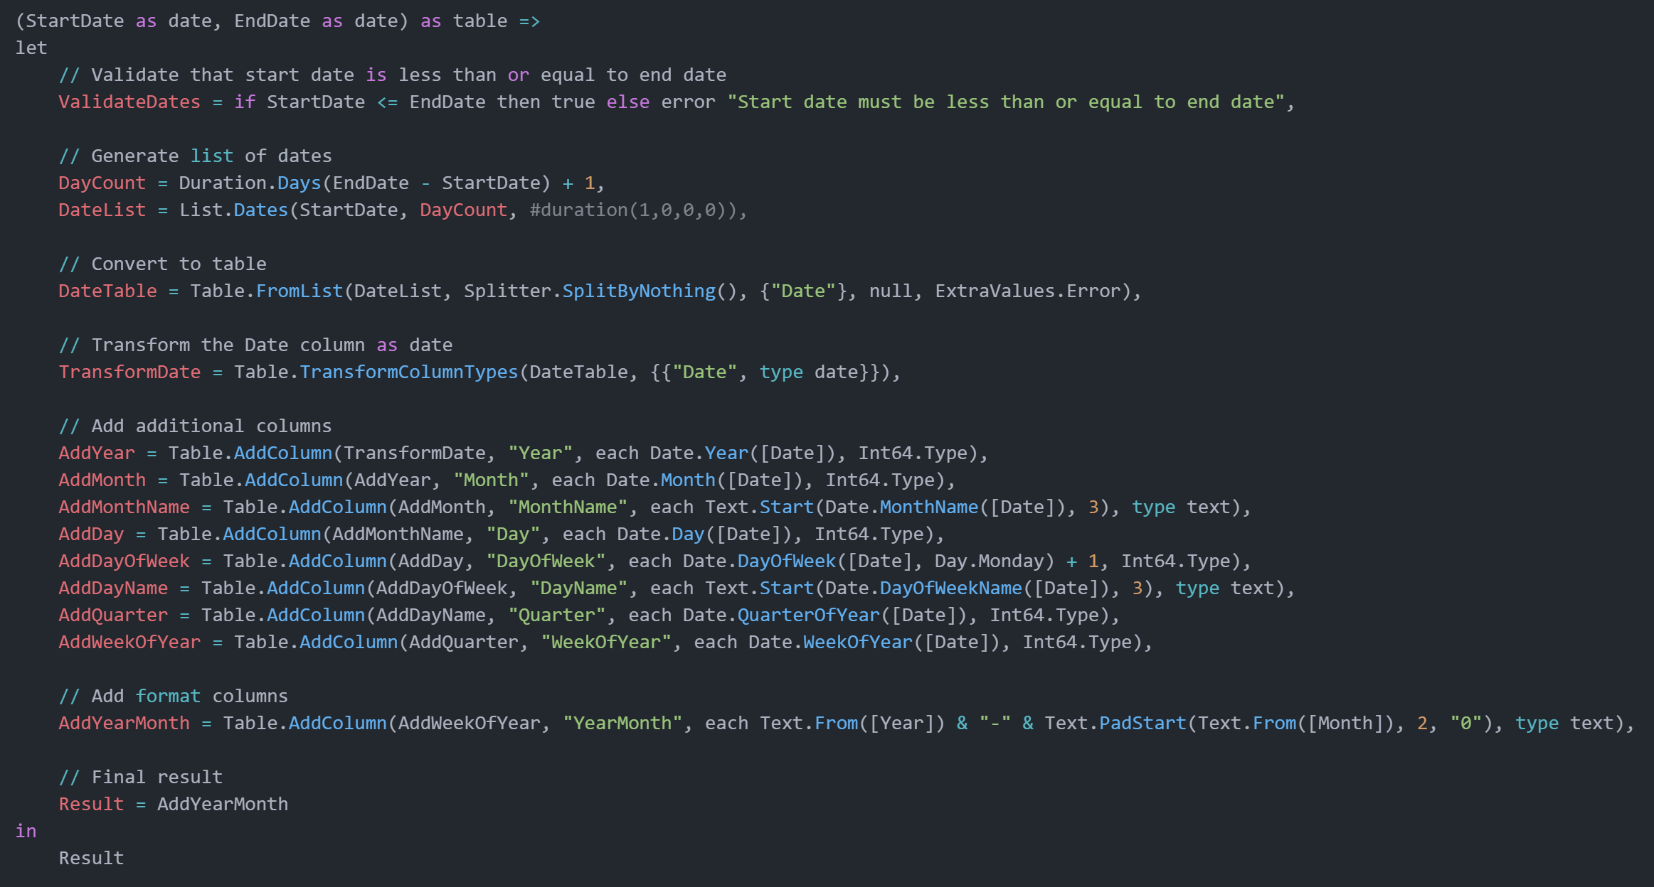

Código M (Ingles)

(StartDate as date, EndDate as date) as table =>
let
// Validate that start date is less than or equal to end date
ValidateDates = if StartDate <= EndDate then true else error "Start date must be less than or equal to end date",

// Generate list of dates
DayCount = Duration.Days(EndDate - StartDate) + 1,
DateList = List.Dates(StartDate, DayCount, #duration(1,0,0,0)),

// Convert to table
DateTable = Table.FromList(DateList, Splitter.SplitByNothing(), {"Date"}, null, ExtraValues.Error),

// Transform the Date column as date
TransformDate = Table.TransformColumnTypes(DateTable, {{"Date", type date}}),

// Add additional columns
AddYear = Table.AddColumn(TransformDate, "Year", each Date.Year([Date]), Int64.Type),
AddMonth = Table.AddColumn(AddYear, "Month", each Date.Month([Date]), Int64.Type),
AddMonthName = Table.AddColumn(AddMonth, "MonthName", each Text.Start(Date.MonthName([Date]), 3), type text),
AddDay = Table.AddColumn(AddMonthName, "Day", each Date.Day([Date]), Int64.Type),
AddDayOfWeek = Table.AddColumn(AddDay, "DayOfWeek", each Date.DayOfWeek([Date], Day.Monday) + 1, Int64.Type),
AddDayName = Table.AddColumn(AddDayOfWeek, "DayName", each Text.Start(Date.DayOfWeekName([Date]), 3), type text),
AddQuarter = Table.AddColumn(AddDayName, "Quarter", each Date.QuarterOfYear([Date]), Int64.Type),
AddWeekOfYear = Table.AddColumn(AddQuarter, "WeekOfYear", each Date.WeekOfYear([Date]), Int64.Type),

// Add format columns
AddYearMonth = Table.AddColumn(AddWeekOfYear, "YearMonth", each Text.From([Year]) & "-" & Text.PadStart(Text.From([Month]), 2, "0"), type text),

// Final result
Result = AddYearMonth
in
Result

Código M (Español)

(FechaInicio as date, FechaFinal as date) as table =>
let
// Validar que la fecha inicial sea menor o igual a la final
ValidarFechas = if FechaInicio <= FechaFinal then true else error "La fecha de inicio debe ser menor o igual a la fecha final",

// Generar lista de fechas
CantidadDias = Duration.Days(FechaFinal - FechaInicio) + 1,
ListaFechas = List.Dates(FechaInicio, CantidadDias, #duration(1,0,0,0)),

// Convertir a tabla
TablaFechas = Table.FromList(ListaFechas, Splitter.SplitByNothing(), {"Fecha"}, null, ExtraValues.Error),

// Formatear la columna Fecha como date
FormatearFecha = Table.TransformColumnTypes(TablaFechas, {{"Fecha", type date}}),

// Agregar columnas adicionales
AgregarAño = Table.AddColumn(FormatearFecha, "Año", each Date.Year([Fecha]), Int64.Type),
AgregarMes = Table.AddColumn(AgregarAño, "Mes", each Date.Month([Fecha]), Int64.Type),
AgregarNombreMes = Table.AddColumn(AgregarMes, "NombreMes", each Text.Start(Date.MonthName([Fecha]), 3), type text),
AgregarDia = Table.AddColumn(AgregarNombreMes, "Dia", each Date.Day([Fecha]), Int64.Type),
AgregarDiaSemana = Table.AddColumn(AgregarDia, "DiaSemana", each Date.DayOfWeek([Fecha], Day.Monday) + 1, Int64.Type),
AgregarNombreDiaSemana = Table.AddColumn(AgregarDiaSemana, "NombreDiaSemana", each Text.Start(Date.DayOfWeekName([Fecha]), 3), type text),
AgregarTrimestre = Table.AddColumn(AgregarNombreDiaSemana, "Trimestre", each Date.QuarterOfYear([Fecha]), Int64.Type),
AgregarSemanaAño = Table.AddColumn(AgregarTrimestre, "SemanaAño", each Date.WeekOfYear([Fecha]), Int64.Type),

// Agregar columnas de formato
AgregarAñoMes = Table.AddColumn(AgregarSemanaAño, "AñoMes", each Text.From([Año]) & "-" & Text.PadStart(Text.From([Mes]), 2, "0"), type text),

// Resultado final
Resultado = AgregarAñoMes
in
Resultado

